**Program no____7_____**

**Program Title______Distance detector_________**

**Aim The light Fades as the sunlight increases**

**Hardware Required**

* Arduino Board

Ultrasonic distance sensor

**Circuit Diagram**

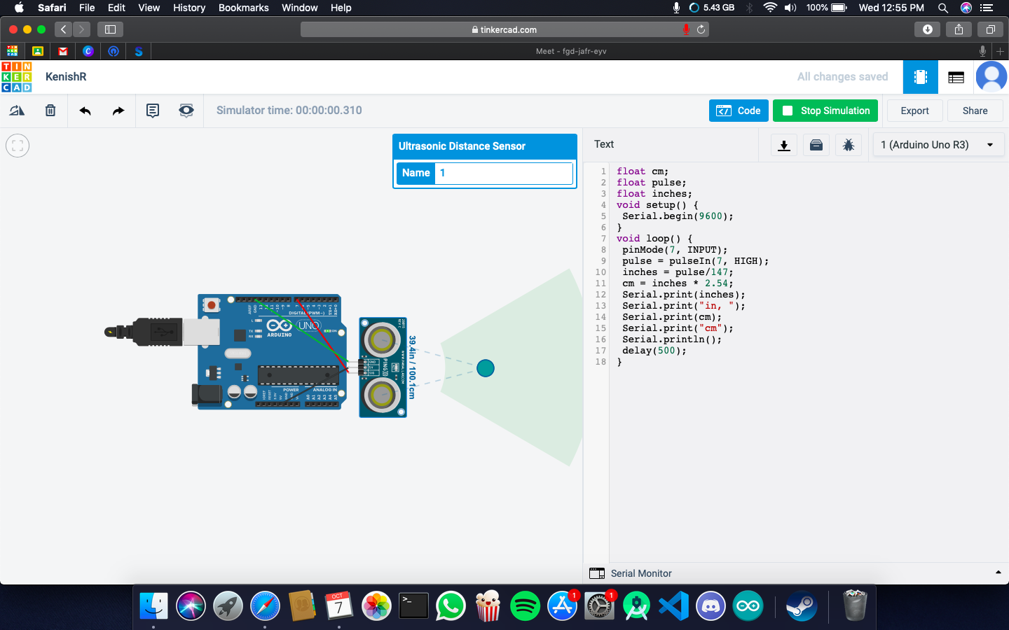

**Code:**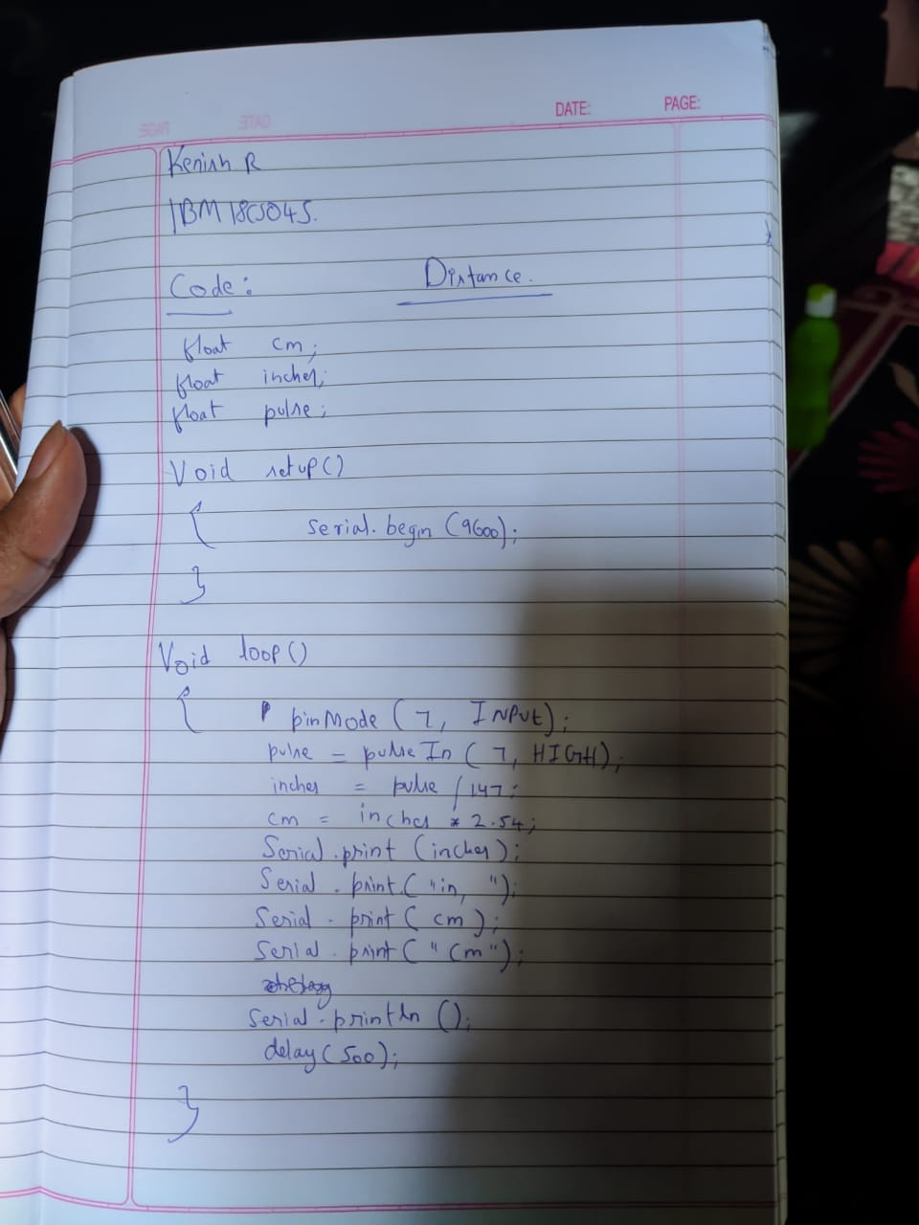

**Observation /Output**

**It will tell the distance in inches and centimetre.**